# Makeba Lee Fund

* [Home](https://newroots.org/)
* Makeba Lee Fund



Makeba Lee (pictured at left) was a 24-year-old mother of one who tragically passed away on May 17, 2012. With the help of Lee’s mother, Ms. Aja Nkrumah, and grandfather, Mr. Ed White, New Roots created a fund in her honor to support mothers who benefit from the [Special Supplemental Nutrition Program for Women, Infants, and Children (WIC).](http://www.fns.usda.gov/wic/women-infants-and-children-wic) With a generous grant from individuals and foundations such as [Women 4 Women](http://www.w4w.org/), the Makeba Lee Fund was born. Thanks to the fund, for just $66 ($6/share) a Family on WIC can purchase fresh fruits and vegetables from New Roots for an entire growing season–approximately five months.

The Fund has finally run out and in December 2017, New Roots launched a campaign to replenish the fund and once again invest in Kentuckiana’s young families, with a goal of reaching $10,000 by May 2018. This will help connect 150 families on WIC to the farm-fresh, local, organic produce we ALL need to be happy and healthy.

New Roots is proud to partner with ChooseWell Communities on the Makeba Lee Fund. This partnership allows New Roots and ChooseWell Communities to hold a vision of a Compassionate City where every family with a child under the age of three thrives in a home free from active substance misuse.

Your donation matches every dollar contributed by ChooseWell Thrive families like Nisey and Zaelynn to make farm-fresh food affordable and accessible for all. Learn more about ChooseWell Communities [here](https://www.choose-well.org/).

Though legal restrictions prevent mothers from using their WIC funds to purchase New Roots produce, anyone with a WIC Card or coupons in southern Indiana or Kentucky is eligible to purchase their shares for six dollars apiece when the growing season kicks off in May, 2018. Just select the $6 option on any Fresh Stop Market’s online ordering page or call New Roots at 502-509-6770 for more information.

To sign up with the Louisville WIC program, please [visit their website](http://louisvillewic.org/wictemplate/english/splash/), or visit one of the following locations in town:

Dixie Health Center

7219 Dixie Highway

Louisville, KY 40258

L&N

908 West Broadway

Louisville, KY 40202

Newburg Health Center

4810 Exeter Avenue

Louisville, KY 40218

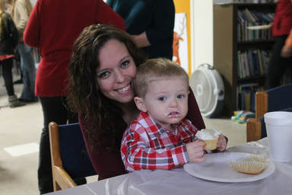

Nisey and Zaelynn, leaders in the ChooseWell Communities Thrive Movement.